**WEEK 5**

**Microservices with Spring Boot 3 and Spring Cloud Hands-On Exercises**

2. Microservices with API gateway

**Hands on**

**Creating Microservices for account and loan**

**AccountController.java**

**package** com.cognizant.loan;

**import** org.springframework.boot.SpringApplication;

**import** org.springframework.boot.autoconfigure.SpringBootApplication;

@SpringBootApplication

**public** **class** LoanApplication {

**public** **static** **void** main(String[] args) {

SpringApplication.*run*(LoanApplication.**class**, args);

}

}

**AccountApplication.java**

**package** com.cognizant.account;

**import** org.springframework.boot.SpringApplication;

**import** org.springframework.boot.autoconfigure.SpringBootApplication;

@SpringBootApplication

**public** **class** AccountApplication {

**public** **static** **void** main(String[] args) {

SpringApplication.*run*(AccountApplication.**class**, args);

}

}

**OUTPUT**

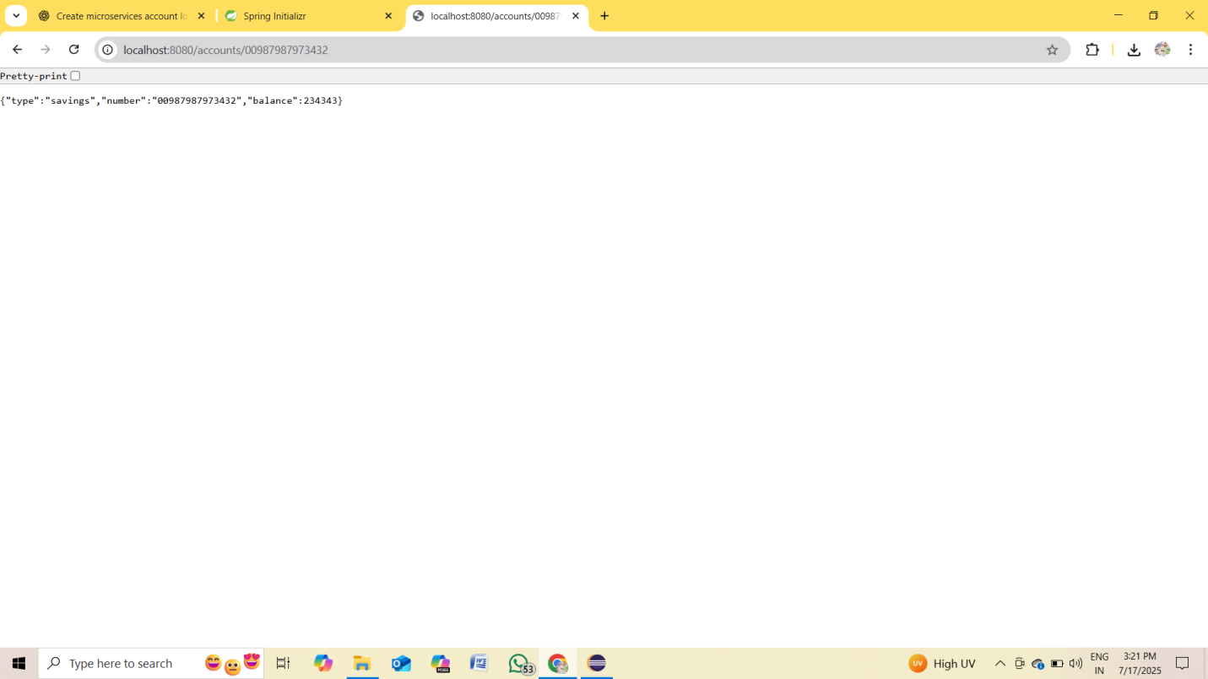

**LoanController.java**

**package** com.cognizant.loan.controller;

**import** org.springframework.web.bind.annotation.*;

**import** java.util.Map;

@RestController

@RequestMapping("/loans")

**public** **class** LoanController {

@GetMapping("/{number}")

**public** Map<String, Object> getLoan(@PathVariable String number) {

**return** Map.*of*(

"number", number,

"type", "car",

"loan", 400000,

"emi", 3258,

"tenure", 18

);

}

}

**LoanApplication.java**

**package** com.cognizant.loan;

**import** org.springframework.boot.SpringApplication;

**import** org.springframework.boot.autoconfigure.SpringBootApplication;

@SpringBootApplication

**public** **class** LoanApplication {

**public** **static** **void** main(String[] args) {

SpringApplication.*run*(LoanApplication.**class**, args);

}

}

**OUTPUT**

